Volume II: Technical Proposal Overview for GPS-XAR
Response to S07-076
Delivered to:
Jane Wells
SAIC-Frederick, Inc.
92 Thomas Johnson Drive
Suite 250
Frederick, MD 21702

Prepared by:
5AM Solutions, Inc.
1625 N 11th Avenue
Phoenix, AZ 85007
Contact: Brent Gendleman
E-mail: bgendleman@5amsolutions.com
Mobile: 602-722-1530

Table of Contents
1. Introduction 1
2. Summary of Project Management Plan 1
2.1 Executive Management Commitment 1
2.2 Software Development Process 1
2.3 Tools 1
2.4 Schedule 1
2.5 Staffing and Roles 2
3. Technical Approach Summary 3
3.1 Phases 3
3.2 Use Case Model 4
3.2.1 Anticipated Actors 5
3.2.2 Use Case Brief Descriptions 5
3.3 Candidate Architecture 5
4. Organizational Qualifications 7
4.1 caArray 1.4 7
4.2 caArray MAGE-ML Loader (caAMEL) 7
4.3 NIH Neuroscience Microarray Consortium Portal 7
4.4 UCLA Web Services Integration with the NIH Neuroscience Consortium 8
4.5 Microarray Enterprise Manager – Open Source 9
4.6 Amyotrophic Lateral Sclerosis Re-sequencing Study 9
4.7 Glial Invasion Tissue Microarray Study 9
4.8 Software Automation and Engineering for Pyramid Systems, Inc. 10
4.9 The System for Collaborative Translational Research (SCTR) 10

Table of Figures
Figure 1 - Proposed Coarse-Grained Schedule with Deliverables 2
Figure 2. Preliminary Use Case Model 4
Figure 3. Rudimentary Candidate Architecture 6

Table of Tables
Table 1 – Role Mapping to Key and Support Personnel. 3
Table 2 – Estimated Team Allocation across Deliverables for the Initial Release of GPS-XAR 3

Table of Appendices
APPENDIX A – Draft Project Management Plan
APPENDIX B – Resumes of Key Personnel and Additional Personnel

Introduction
This document represents 5AM Solution’s technical proposal in response to Science Applications International Corporation – Frederick, Inc.’s (SAIC-Frederick) solicitation S07-076. The development of the General Proteomics Standard tool for eXperiment ARchive format (GPS-XAR) for the National Cancer Institute Center for Bioinformatics (NCICB), as described in the Statement of Work (SOW) is aligned with our mission, talent, and experience. 5AM was founded specifically to serve the life sciences community through the development of innovative software solutions that enable sharing research data across traditional boundaries. We have built open-source, web-based portal software in use nationally with thousands of users. We have gained adoption at caBIG institutes by being responsive, flexible, and quick to deliver modifications by working directly with the end users. Within the past year we have delivered the caArray MAGE-ML Loader (caAMEL) and have evolved the code base for caArray into two significant point releases.
Our development approach is based on the transparent development of open-source, component-based software. We are in-synch with the cancer Biomedical Informatics Grid (caBIG) initiatives (Open Source, Open Access, Open Development and Federation). Our proven success at building web solutions that allow for the validation, parsing and loading of experimental annotations along with the underlying raw data on a national scale enables 5AM to efficiently deliver on GPS-XAR.
5AM’s overall software development process is guided by our tailored implementation of IBM’s Rational Unified Process (RUP). 5AM’s progress and artifacts for the caAMEL and caArray project are available through the NCICB’s G-Forge site and we will be able to build upon our experience using this set of tools. We employ best practices that emphasize risk mitigation, sound software engineering, and automation to ensure that the right solution is built on time and within budget.

Summary of Project Management Plan
This section provides a summary of our Project Management Plan. The complete Draft Project Management Plan is included as Appendix A of this proposal.

Executive Management Commitment
This project is of strategic importance to 5AM Solutions, so it will receive constant attention from senior management. In recognition of this importance, 5AM Solutions has assigned an officer of the company and experienced Project Manager (PM) responsible the overall project and its deliverables. Acting as coach, sheep dog, and mouthpiece, the PM will be both aware, and make concerned parties aware, of all progress and hindrances to progress for the project.

Software Development Process
5AM boasts repeated success in the application of the Rational Unified Process (RUP) to drive its software development. All of our team members have been through multiple projects together using the RUP, and it has become second nature on all projects we undertake. Additionally, in the quest for never-ending improvement, 5AM has continually reduced the amount of overhead expended applying the RUP, and have carefully managed to incorporate several “agile” tenets to further increase productivity.

Tools
5AM’s standard project management methodology includes the use of various software packages to assist the planning, monitoring, controlling, and reporting of the work efforts. For the GPS-XAR effort, we will de-emphasize many of our own tools (e.g., the Rational Tool Suite and MagicDraw) in the interest of integrating well with other caBIG projects. For modeling we will use Enterprise Architect, for requirements and change request tracking we will use the trackers provided within GForge and for Software Configuration Management (SCM), we will use the NCICB-provided cvs repository. Finally, to support and encourage open access and open development, all artifacts including documents, schedules, source code, quality reports, and test results will be exposed via G-Forge.

Schedule
The schedule is both iterative and incremental. The schedule is broken into a series of iterations, each one resembling a miniature waterfall lifecycle composed of traditional disciplines, including requirements analysis, design, coding, and test. Not all iterations will result in a deployable work product, though each one should provide us with objective and measurable results, which in turn can be used to further refine future iterations. Successive iteration will add more and more features to the work product, so that macroscopically, we will see incremental growth of the deployable features of the system.
Figure 1 illustrates the essential schedule, complete with identified deliverable milestones. It is important to stress that, due to the nature of an iterative and incremental process; we expect to return to already-delivered assets as subsequent iterations reveal the necessity for refinement of them.
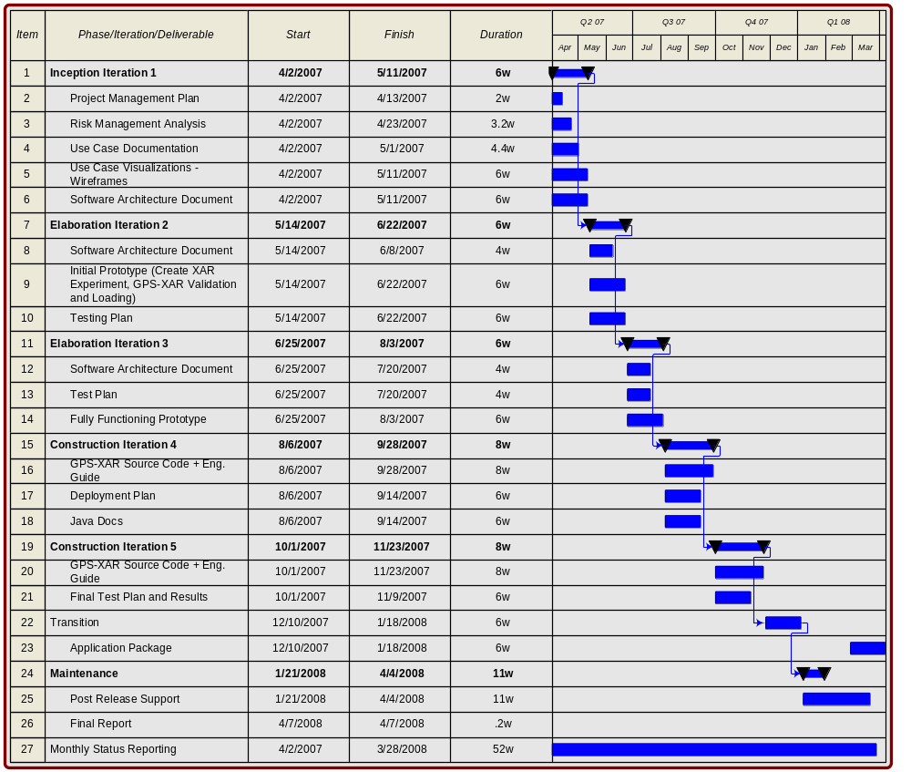
Figure 1 - Proposed Coarse-Grained Schedule with Deliverables

Staffing and Roles
Following the core disciplines and typical RUP lifecycle, a small team initially will support the project. The team size will peak during the height of implementation and then decreased in size following successful transition from delivery of GPS-XAR into a maintenance lifecycle that may introduce point releases (i.e., 1.0.1, 1.0.2, etc.). The following tables identify team members, their role(s), and anticipated utilization for each item identified in the RFP. Table 1, Role Mapping to Key and Support Personnel, lists both key and support personnel. Key personnel will support the project full time and are denoted with an asterisk “*”. The support personnel listed will be used as needed as the project plan is updated. Greater role definition is described in the Project Management Plan.
Role | Key* and Support Personnel
Project Manager (PM) | Brent Gendleman, Rob Daly
Software Architect (SA) | Krishna M. Kanchinadam*, with support from Eric Tavela and Rob Daly
Senior Requirements Analyst (SRA) | Brent Gendleman
Developer (DEV) | Krishna M. Kanchinadam*, Scott Miller
Graphical User Interface | Brent Gendleman with support form Scott Miller
Test Manager (Dev2) | Scott Miller with support from Steve Matyas
Table 1 – Role Mapping to Key and Support Personnel.
We anticipate having 2.5 full time equivalents for the entirety of the project’s duration. Krishna M. Kanchinadam will be on the project from day one, whereas the additional resources will be targeted for smaller durations.

Deliverable | Effort (hours) | Contribution across team
Deliverable | Effort (hours) | PM | SA | SRA | Dev | Dev2 | GUI | Test | Total
Project Plan | 60 | 50% | 50% |  |  |  |  |  | 100%
Monthly Status Report | 96 | 100% |  |  |  |  |  |  | 100%
Weekly Reporting/Updates | 104 | 100% |  |  |  |  |  |  | 100%
Risk Management Analysis and Use Case Document | 384 | 65% | 35% |  |  |  |  |  | 100%
Software Architecture Document | 360 |  | 75% |  | 25% |  |  |  | 100%
Test Plan | 120 | 5% | 15% |  | 40% | 40% |  |  | 100%
GPS-XAR Source Code with Engineering Guide | 2240 | 5% | 45% |  | 45% | 5% |  |  | 100%
Deployment Plan | 120 |  | 15% |  | 80% | 5% |  |  | 100%
Java Docs | 120 |  | 25% |  | 75% |  |  |  | 100%
Test Results | 255 |  | 5% |  | 75% | 20% |  |  | 100%
Application Package | 240 | 5% | 50% |  | 45% |  |  |  | 100%
Final Report | 32 | 40% | 60% |  |  |  |  |  | 100%
Post Release Support | 880 |  | 50% |  | 50% |  |  |  | 100%
Effort Total | 5011 |  |  |  |  |  |  |  | 100%
Table 2 – Estimated Team Allocation across Deliverables for the Initial Release of GPS-XAR

Technical Approach Summary
As mentioned above, we employ the RUP as our software development process and organize development activities into iterations that fall within specific phases. The following summary indicates how the significant design and implementation activities fall within this outline. A detailed description of these activities organized by iteration is found in our Draft Project Management Plan.

Phases
Inception – In this phase we focus on organizing and refining the requirements set (those identified in the SOW and those proposed by the user community) and understanding the technical impact of the requirements. Understanding and describing the key relationships between CPAS, the NCI-CPTAC Ontology and the complexity of the XAR schema will be a major goal for establishing a candidate architecture that will be exercised in Elaboration.
Elaboration – In this phase we will implement the riskier elements of the architecture designed during Inception, parsing and validation of the XAR file, establish the mechanism for integrating the NCI/CPTAC Ontology and converting CPTAC data into a XAR file for uploading into CPAS. We anticipate this will be done in two (2) iterations. This phase culminates in an executable architectural prototype that demonstrates that we have mitigated all significant technical risks.
Construction – In this phase we complete the implementation of all components. This includes refinement of the components implemented in Elaboration and the implementation of all requirements that were not deemed to carry significant architectural risk, such as the generation of XAR files, generation of the API and ensuring that the current CPAS pipeline of analysis tools can accurately read the data loaded by GPS-XAR. The key artifact resulting from this phase is a complete beta release of GPS-XAR.
Transition – In this phase we refine the implementation to fix any defects found in the beta release and we work to further refine the installation and documentation artifacts for the release. This phase results in a production release of GPS-XAR for installation at the NCICB and by the adopter community.
Maintenance – In this phase we provide the ongoing support of GPS-XAR by providing incremental releases that include defect fixes and ongoing enhancements as directed by the program management and by the user community.

Use Case Model
The following is a preliminary use case model that represents the anticipated actors and the key functions they will execute in the GPS-XAR system.

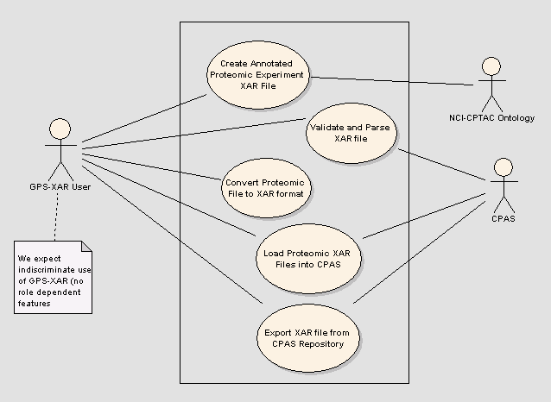
Figure 2. Preliminary Use Case Model

Anticipated Actors

GPS-XAR User – we anticipate that any user of the CPAS system should be able to perform any of the functionality provided by GPS-XAR. Therefore, we show only the generic actor here without restriction. Note: this may change based on group permissions available in CPAS which would impact the projects that could be acted upon but still not restrict the actions the user can take.

CPAS - This represents the Computational Proteomics Analysis System (CPAS) developed by Fred Hutchinson Cancer Research Center, on which the NCICB proteomics repository is based on and is the application that the GPS-XAR system will need to integrate with by providing and pulling data from it.

NCI-CPTAC Ontology – This actor represents an evolving ontology through which the GPS-XAR system is expected to pull key vocabulary terms to allow the GPS-XAR User to annotate their proteomic experiments.

Use Case Brief Descriptions
Create Annotated Proteomic Experiment XAR File – Initiated by a GPS-XAR User, this use case enables the building of a XAR file complete with experiment annotations concerning Material, Data, Protocol, Protocol Application, Experiment Run, and Experiment using one or more standard ontology’s.

Validate and Parse XAR File – Initiated by a GPS-XAR User, this use case supports the selection of a file in XAR format for validation of the XML structure and the content of the file, with clear and complete indications of whether the validation was successful or what specific errors were encountered.

Convert Proteomic File to XAR Format – Initiated by a GPS-XAR User, this use case allows for the selection of a proteomic data file for conversion into the XAR format. Once converted, the ability to validate, parse and load the file will be available.

Load Proteomic XAR Files into CPAS – Initiated by a GPS-XAR user, this use case allows for the import of a valid, parsed Mass Spectrometry XAR file into the CPAS repository.

Export XAR File from CPAS Repository – Initiated by a GPS-XAR User, this use case allows for the selection of an experiment from the CPAS repository for export as a XAR file.

Candidate Architecture
Though the design will need to be adjusted due to requirements refinement and issues uncovered during Inception, this rudimentary design provides a foundation that addresses the needs for GPS-XAR. Based on our experiences, we believe that the following factors must be addressed.
- A Model Driven Architecture (MDA) based approach to generating validation and loading functionality will save considerable implementation effort.
- An optimal design of the validation functionality would provide a unified interface to multiple validation approaches (GUI and batch-based). Also, the validation components should allow for local installation and use by external CPAS clients.
- A Web Services interface to loading and validation services is highly desirable.

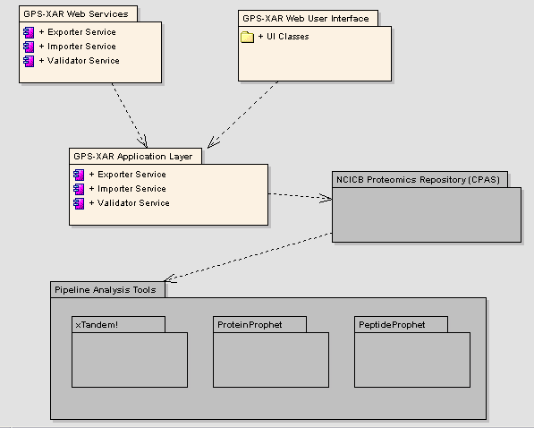
Figure 3. Rudimentary Candidate Architecture

Candidate Architecture – Brief Description
The above diagram identifies the major subsystems and packages that are envisioned in the system. At the highest level, the proposed design is a J2EE web application employing a Model-View Controller architecture, using industry standard frameworks. The application will also expose a SOAP Web Services interface for clients that wish to access the system functionality programmatically, as opposed to manually via the web user interface.
The packages in gray, namely the NCICB Proteomics Repository (CPAS) and the Pipeline Analysis Tools, are pre-existing software modules and will not be modified. The GPS-XAR system will integrate with the CPAS module and not modify it in any manner.
A brief description of each package is given below:
GPS-XAR Web Services – This package serves as the SOAP enabled web service layer for GPS-XAR. This will expose services to validate XAR files, Import proteomic data in XAR format from CPAS and Export proteomic data in XAR files into CPAS, to be consumed by external clients programmatically. This module is dependant on the GPS-XAR Application Layer to provide the above-mentioned services.
GPS-XAR Web User Interface – This represents the GPS-XAR web user interface layer. It consists of user interface classes and provides functionality for validating XAR files, importing XAR data files into CPAS and exporting proteomic data in XAR format from CPAS. Similar to the web services module, this module depends on the GPS-XAR application layer to provide the functionality.
GPS-XAR Application Layer – This layer incorporates the functionality for actually validating XAR files and importing and exporting XAR files to and from CPAS. The Web Services and User Interface layers are dependant on this layer to provide the desired functionality.
NCICB Proteomics Repository (CPAS) – This denotes the CPAS based Proteomics Experiment data repository hosted at the NCICB. This external sub-system integrates with various Pipeline analysis tools.
Pipeline Analysis Tools – This represents systems like xTandem!, PeptideProphet, ProteinProphet, that integrate with the CPAS based NCICB proteomics repository.

Organizational Qualifications
5AM is uniquely qualified to meet the requirements of the SOW. 5AM has the technical prowess, experience, and resources to ensure successful completion of the project as described in the budget outlined in our cost proposal. Highlighted below are several efforts that support 5AM’s organizational qualifications.

caArray 1.4
Period of Performance/Development: July 17, 2006-current
Contract Value: $1,133,557.50
Reference Contact: Director, Application Engineering NCICB, Anand Basu phone: 301-496-3459 e-mail: basuan@mail.nih.gov
caArray has two objectives: the first is to make microarray data publicly available; the second is to develop and bring together open source tools to analyze the data generated. The releases that 5AM has developed (1.4 and soon to be release 1.5) facilitates those objectives by allowing NCI-affiliated researchers from around the nation to add their findings to caBIG. The ability to quickly validate and upload data to caBIG means that progress in all facets of cancer research will be accelerated with cancer patients being the project’s most important beneficiaries.

caArray MAGE-ML Loader (caAMEL)
Period of Performance/Development: March 20, 2006-July 28, 2006
Contract Value: $141,997.93
Reference Contact: caArray Product Manager, Mervi Heiskanen, Ph.D. phone: 301-451-6369 e-mail: heiskame@mail.nih.gov
caAMEL is a web-based application that validates MAGE-ML documents, and more importantly, loads the data contained within valid MAGE-ML documents into a caArray repository. caAMEL exposed this functionality via a web-based user interface, a web services interface, and direct integration with caArray. The caAMEL project is sponsored by the National Cancer Institute Center for Bioinformatics (NCICB) with project management oversight being conducted by Booz-Allen-Hamilton.
Designing the integration of caAMEL with caArray has provided 5AM with a deep understanding of the existing caArray architecture. Additionally, the performance profiling of caArray performed during design evaluation has provided 5AM with insight into performance bottlenecks and potential improvements to the existing caArray design.

NIH Neuroscience Microarray Consortium Portal
Period of Performance/Development: June 1, 2003- May 30, 2005
Contract Value: $210,208
Period of Performance/Maintenance: June 1, 2005- May 30, 2010
Contract Value: $30,000 Annual
Reference Contact: NNMC Chairman, Dietrich Stephan, Ph.D. phone: 602-343-8727 e-mail: dstephan@tgen.org
The NIH Neuroscience Microarray Consortium was created to initially extend the services of three microarray processing Centers of Excellence (TGen, UCLA, and Duke) to all holders of either a NINDS or NIMH grant, enabling them to further their research by working with acknowledged experts in the microarray field. The consortia model requires data be collected, managed and distributed consistently across organizations and to the public. Each center had its own infrastructure, tools, and techniques that needed to be integrated. Several applications were available that would address one set of requirements, but none that would address them all simultaneously, particularly across institutions. No solutions mirrored the natural workflow of experiments, enabled cross-organizational collaboration, administration and billing, displayed views of project progress and produced verifiably MIAME-compliant MAGE-ML.
Guided by leading scientists from TGen, UCLA, Duke, NIH Program Administrators and the Consortium’s Advisory Panel, delivered a web-based software system to meet these needs. 5AM improved the ease of enforcing MIAME compliance by verifying compliance as soon as data was entered and at key milestones in the workflow - using the guidelines, exchange standards and software development kits provided by the Microarray Gene Expression Data Society (MGED) as significant inputs. We continue to maintain and evolve the solution, now entering its third generation. The portal can be viewed by visiting http://arrayconsortium.tgen.org. The solution, called 5AM’s Microarray Enterprise Manager (MEM) was recognized by IBM Life Sciences as a showcase solution and a Beacon Finalist and was selected as a finalist for the Arizona Governor’s Celebration of Innovation Award. 5AM has made MEM available as an open-source project at SourceForge and invested an additional $200,000 to ensure that what was built could be extended without restriction to future projects.
The Consortium expanded to serve researchers across 15 NIH Institutes on June 1, 2005, in part because the solution was scalable and strategically fit the NIH Blueprint for Neuroscience. Yale University was added and the investigator pool that the consortium will serve increased to 10,000 users – executed without re-engineering the solution. The Consortium currently serves 1,150 registered users working on 168 projects.
This project is of particular relevance to the caArray 1.4 proposal. First, at its core, the system is based directly on the MAGE-OM. In order to efficiently implement the MAGE persistence subsystem, we chose to use an automated MDA transformation to create a persistence handler for each of the 128 classes in the MAGE model. The success of this approach enabled us to deliver complex functionality while focusing our resources on other, more novel aspects of the system. One of these aspects is the MIAME validation framework, which wraps the underlying MAGE objects and provides validation according to the MIAME guidelines.

UCLA Web Services Integration with the NIH Neuroscience Consortium
Period of Performance: August 8, 2004- November 22, 2004
Contract Value: $25,000
Reference Contact: Stan Nelson, Ph.D. phone: (310) 794-7981 e-mail: snelson@ucla.edu
UCLA’s DNA Microarray Core is one of four centers working under the NIH Neuroscience Microarray Consortium. The investigators that use their Core Facility come from a variety of places and UCLA created a web system prior to the consortium’s existence for managing projects. UCLA’s Gene Expression Core (GEC), built on the open source ArsDigita Community System (ACS) software, needed to be able to exchange data with the Consortium system. The main problem was that projects assigned to UCLA from the Consortium required redundant entry on the part of the lab researchers and their customers. Regardless of where projects originated, they needed to be tracked in the custom UCLA system. While similar in intent the two systems had different requirements and designs.

5AM and the UCLA Control team undertook a collaborative effort to identify the appropriate points in the workflow where bi-directional data exchange should occur. After a brief Inception, the two identified integration points were project approval and completion where large amounts of data (hundreds of megabytes) would need to acquired, extracted and readied for publication. We identified the data to be exchanged, defined XML schemas for the data, and designed and implemented services interfaces for each application. Upon assignment of a project to UCLA, the Consortium solution automatically invokes the service interface in the GEC system to pass it the initial project data. Lab technicians then use the GEC system during execution of the experiment. Once the experiment is complete, GEC sends all project annotation and array data via the service interface on the Consortium side. The Consortium project is updated with any additional annotation and the array data is extracted for analysis and publication to the National Center for Bioinformatics (NCBI)’s Gene Expression Omnibus (GEO).

Microarray Enterprise Manager – Open Source
Period of Performance: December 29, 2005-current
Contract Value: $21,250 (open source)
Reference Contact: Yate-Ching Yuan, Ph.D. phone: (626) 359-8111 x-62161 e-mail: yyuan@coh.org
A current adopter of the solution initially developed for the NIH Neuroscience Microarray Consortium, Dr. Yuan can attest to the ease of implementation and the installation instructions provided by 5AM Solutions through our SourceForge project in addition to experiencing our ability to customize the software to their explicit needs. Currently the system is in the second development iteration and will be initially deployed to production by the end of March. Our initial effort centered around porting the application from an IBM-centric environment (WebSphere and DB2) to an open-source environment (JBoss and MySQL); the next effort was to tailor the workflow management to their specific needs where we split the roles of lab scientist into one that supports the technician and the statistician.

Amyotrophic Lateral Sclerosis Re-sequencing Study
Period of Performance: February 1, 2006 – March 9, 2006
Contract Value: $20,000
Reference Contact: Dietrich Stephan, Ph.D. phone: (602) 343-8727-mail: dstephan@tgen.org
The Translational Genomic Research Institute (TGen) was awarded a Milestone Grant by the Muscular Dystrophy Association to perform a 9-month project targeted to rapidly re-sequence the “variable human genome” at high enough density to allow the identification of the DNA variants (single nucleotide polymorphisms or SNPs) which predispose to people to amyotrophic lateral sclerosis (ALS). An understanding of the DNA changes that give rise to ALS predisposition will allow diagnostics to be developed in the short-term. The end products of this initial 9 month project will be to develop a multi-gene diagnostic test for sporadic ALS, and new targets to develop therapeutics for the common form of sporadic ALS.
5AM customized Illumine, our flexible internet-based J2EE application that provides a foundation to medical researchers, clinicians, physicians, therapists, and scientists to collaborate and communicate in the context of a research project. Using the features that support enrollment, clinical data collection, specimen creation and tracking, 5AM was able to launch the study over a month’s time. As many as 40 clinical sites are necessary to acquire 1,500 ALS patient blood samples. Clinical site representatives will collectively enter and approve clinical data, be reminded to update the status of the patients including prospective clinical data points, and track the samples they send. TGen will indicate receipt and storage of the samples, indicate quality control measures taken and allocate the samples into the initial training set (500 samples) or the validation sets (the next 500). TGen also will record the location of the data results for each sample and expose the de-identified data to all registered users with the appropriate roles. Rapid progress in ALS therapeutics can be fostered through this multi-institutional and multi-disciplinary approach that spring from work on shared clinical and genomic material that is well annotated.

Glial Invasion Tissue Microarray Study
Period of Performance: January 1, 2005 – March 1, 2005
Contract Value: $45,000
Reference Contact: Michael Berens, Ph.D. phone: (602) 850-7009 e-mail: mberens@tgen.org
The Translational Genomic Research Institute (TGen) envisioned a research study where they would prepare a series of 3-4 composite tissue microarray (TMA) blocks by requesting 3 clinically annotated, properly consented brain tumor specimens from at least 15 institutes around the world. Once the tumors were sent and organized into the blocks, slides from the blocks representing 45 tumors would be cut and distributed back to collaborators with unique immunohistochemistry (IHC) expertise to evaluate the expression of candidate markers on the tissue section. All results would be made available to the collaborators for testing hypotheses related to specific molecular markers and glioma behavior (proliferation, progression, invasion, survival, patterns of recurrence, location of recurrence, etc.). The end goal was to sharpen, accelerate and refine the use of multi-institutional specimen collections to develop new diagnostic markers, prognostic leads and therapeutic targets for brain cancer and serve as a model for future collaborative studies. TGen needed a way to connect international researchers, direct and share clinical, lab, and genomic research data, while at the same time protecting the privacy of individuals and access to the data at very discrete levels.
Orchestrating the logistics and information technology just in terms of subjects, researchers, and specimens represented a significant and potentially cost prohibitive challenge. Particularly burdensome was the idea that all data submitted would have to be manually reassembled at TGen. The global distribution of the collaborators - from the U.S., Europe and Asia - prevented the integration of each institution’s systems due to time, overall expense, and tremendous risk. Adding to the challenge was the requirement to associate each tumor specimens’ clinical data with the block and slide creation, as well as managing slide distribution and directing the data to be collected against those slides. Any implemented system would have to ensure compliance with the Health Insurance Portability and Accountability Act (HIPAA) and Part 11 of the Code of Federal Regulations (CFR-11) governing Electronic Records and Electronic Signatures for U.S. collaborators.
5AM customized Illumine, our flexible internet-based J2EE application that provides a foundation to medical researchers, clinicians, physicians, therapists, and scientists to collaborate and communicate in the context of a research project. Using the features that support enrollment, clinical data collection, specimen creation and tracking, 5AM was able to launch the study over a month’s time. Next, using the Illumine framework and guided by the researchers, 5AM was able to create the modules required for organizing the block and slide creation and distribution mechanisms, in addition to the unique data requirements for the IHC scoring of the slides and the ability to extract all the relational data while preserving the integrity of patient confidentiality. 5AM also provides secure hosting, hourly data backups, online help and technical support.

Software Automation and Engineering for Pyramid Systems, Inc.
Period of Performance/Development: July 11, 2005- current
Contract Value: $200,000
Reference Contact: Jeff Hwang. phone: 703-995-0111 e-mail: jhwang@psi-it.com
5AM Solutions, Inc. assisted Pyramid Systems, Inc. and the Office of Community Planning and Development (CPD) of US Department of Housing and Urban Development (HUD) as a part of the re-engineering for the Title V Property Management System and the creation of a companion Base Realignment and Closure Management System. Together these web-based management information systems demonstrate the initiatives within CPD and HUD to improve their internal efficiency and support of communities.
PSI also employed 5AM to improve how they develop and deliver software. One of the goals for 5AM was to demonstrate the delivery of reliable software on a consistent schedule while operating on or under budget. To do so, we focused on quality through automation. The approach was multi-faceted consisting of hands-on mentoring, on the job training, formal lectures, and enforcement of the fundamentals of software development. 5AM’s techniques included utilizing continuous integration as the centerpiece for quality, continual technical and business risk evaluations, daily standup meetings, regularly scheduled technical training sessions and presentations. What’s more, we met with the client, CPD-HUD, on a reoccurring basis, every two weeks during which we conducted scaled down user acceptance testing and requirements elicitation sessions.

The System for Collaborative Translational Research (SCTR)
Period of Performance/Development: Mar 1, 2001- Jun 1, 2001 (Inception), and Jul 1, 2001- Dec 30, 2001 (remaining phases)
Contract Value: $1,200,000
Reference Contact: Robert Hotchkiss, MD. phone: 212-606-1862 e-mail: HotchkissR@hss.edu
The System for Collaborative Translational Reaserach (SCTR) was led and built by the founders of 5AM Solutions while with Number Six Software, Inc., this web-based clinical research system was delivered in 2001 to the Hospital for Special Surgery (HSS) in New York, NY. The contract was fixed price for $1.2M, built from idea to delivery over 5 person years and 10 calendar months and is still in use today without maintenance from us. Independent Verification and Validation was performed by Cap Gemini Ernst & Young. We have a license agreement with HSS to use and extend the code base on a study by study basis and it currently is the engine behind the studies we’ve been able to deploy for TGen and their collaborators mentioned above. Initially built for two collaborative and multi-disciplinary orthopedic studies (that involved Dr. Stephan as a key collaborator), the researchers have been able to create 25 additional studies. They have published papers using data from the system, and have acquired additional grant funding to support their research initiatives.

